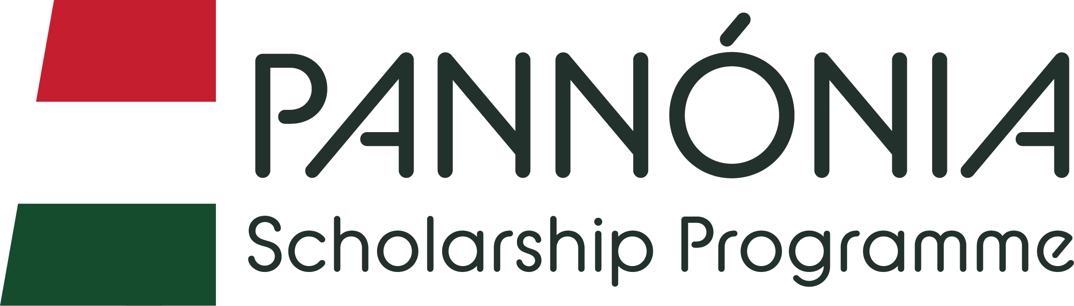

CERTIFICATE OF ATTENDANCE

Pannonia Program 2024/2025
Staff Mobility for Teaching

NAME AND SURNAME OF THE PARTICIPANT: …………………………………………
HOME UNIVERSITY: Hungarian University of Sports Science
HOST UNIVERSITY: ……………………………………………………………………………

It is hereby certified that, ………………………………. (name), the staff of the Hungarian University of Sports Science participated in staff teaching between the ….. (day) of …………………. (month) and the ….. (day) of …………………. (month), 2025 in the framework of the Pannonia Program.

It is hereby certified, that …………………….. (name) has taught minimum 8 hours during the mobility.

The Content of the mobility is part of the Mobility Agreement.

Name: ……………………………......

Title: ………………………………….

Signature: ……………………………
Date:..…/ ..… /2025

