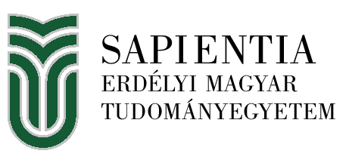
Information Sheet 2025/2026
Name of the institution | Universitatea Sapientia din Cluj-Napoca  (Sapientia Erdélyi Magyar Tudományegyetem)
Erasmus code | RO CLUJNAP07
Website | https://sapientia.ro/hu
Institutional Erasmus+ Coordinator | PÁLL Zita, erasmus@sapientia.ro
Faculty of Economics, Socio-Human Sciences and Engineering, Miercurea Ciuc | Csíkszereda / RO-530104 Miercurea Ciuc, Piaţa Libertăţii nr. 1., Harghita county  Faculty Erasmus+ Coordinator: BORS Hortenzia  e-mail: borshortenzia@uni.sapientia.ro  website: https://csik.sapientia.ro/hu
Faculty of Sciences and Arts, Cluj-Napoca | Kolozsvár / RO-400193 Cluj-Napoca, Calea Turzii nr. 4., Cluj county  Faculty Erasmus+ Coordinator: SIPOS Ottilia  e-mail: kv.erasmus@kv.sapientia.ro  website: https://kv.sapientia.ro/hu
Faculty of Technical and Human Sciences, Targu Mures | Marosvásárhely / Targu Mures - Corunca, Calea Sighișoarei nr. 2., Mures county  Faculty Erasmus+ Coordinator: MOLNÁR Apollónia  e-mail: sapierasmus@ms.sapientia.ro  website: https://ms.sapientia.ro/hu
Faculty of Life Sciences and Sports, Sfantu Gheorghe | Sepsiszentgyörgy / RO-520036 Sfantu Gheorghe, str. Ciucului nr. 50., Covasna county  Faculty Erasmus+ Coordinator: CSIBI Márta  e-mail: sepsi.erasmus@uni.sapientia.ro  website: https://sepsi.sapientia.ro/hu
Academic calendar | https://sapientia.ro/hu/oktatas/hallgatoknak/tanevszerkezet
Course catalogue | https://sapientia.ro/hu/nemzetkozi-kapcsolatok/erasmus/vendegek/targylistak  All courses are in Hungarian, we offer courses in English only on demand.
Nomination, application, accomodation: | Please write an e-mail to the Faculty Erasmus+ Coordinator with the basic data of the selected student(s), and the student will receive an e-mail with the Application Form.  Nomination deadline: 15 May / 15 November  Application deadline: 30 May / 30 November

